C. IMPLEMENTATION

1. Institutional and Implementation Arrangements

- Current Institutional Framework: Helvetas, an international NGO, is currently the implementing agency for the multi-donor funded EF that receives support from the SDC and the DFID and serves as the EFS. The EF and the EFS operate under the overall guidance and oversight of the EFSC. The EFSC is chaired by the Joint Secretary of the MoE, with representation of other government agencies and development partners who contribute to the EF. General administrative and fiduciary procedures of Helvetas are applied for managing the EF activities, and the EFSC approved in 2008 the EF Operating Guidelines. The current institutional framework for the EF is depicted in Figure 1 below.

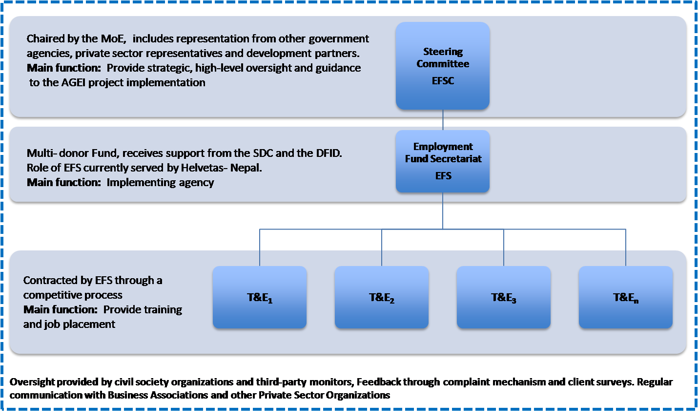
Figure 1. Institutional Model of the Employment Fund

- Implementing Agency: The AGEI will build on the existing implementation arrangements of the EF with some modifications. These implementation arrangements have already been tested and found suitable by the SDC and the DFID. The Bank conducted a detailed assessment and concluded that the existing arrangements provide a sound basis for implementing the AGEI. To this end, with concurrence from the GoN, Helvetas will be charged with overall AGEI implementation as the implementing agency, and AGEI funding will be provided as a Recipient Executed Trust Fund Grant to Helvetas.

- Adaptation of the EF Guidelines: While ensuring that the AGEI grant is “earmarked” within the EF for agreed activities for the target beneficiaries, the AGEI will work within the broad framework of the existing EF Operating Guidelines. However, the guidelines will be suitably modified with the agreement of the EFS, the EFSC and Bank by project effectiveness. This will help ensure that the AGEI supports the ongoing activities of the EF, while also contributing to strengthened procedures and systems within the EF and by its implementing partners.

- EF Steering Committee: As stated above, the EFSC is chaired by the Joint Secretary of the MoE and includes representation from other government agencies, private sector representatives and development partners. It will provide strategic, high-level oversight and guidance to the AGEI implementation; review, advise on and approve annual work plans, budgets and activities; review annual progress and performance based on systematic M&E information; and address serious coordination, management and policy issues. The Bank will not be represented on the EFSC to maintain an arms length relationship from the implementation of the AGEI, given its role in funding and supervising the activities of the AGEI.

- Wider coordination mechanisms include the SDC-hosted donor coordination group for vocational training and the newly established high-level GoN Committee for policy level coordination of the TEVT sector. The latter is facilitated by the National Planning Commission. The EFSC is expected to participate in both of these groups.

- T&E Providers: At the frontline of the delivery of the AGEI will be the T&E providers, selected and contracted by Helvetas to provide technical and life skills training and to ensure job placement. The institutional arrangements between the EF and the T&E providers will be guided by the EF Operating Guidelines. As per these guidelines, the T&E providers are selected through a competitive process in which proposals are screened for technical and financial criteria. Once selected, the T&E providers bear the responsibility to do outreach, recruit and screen applicants, select participants, provide theoretical, practical, and on-the-job training, place trainees into jobs, follow up with trainees, conduct internal monitoring, and verify incomes of trainees after 3 and 6 months of training. The T&E providers are compensated according to the number of students trained and placed and receive additional financial incentives to recruit from particular disadvantaged groups.

- Role of Civil Society and Business Associations: The AGEI will include an explicit role for civil society organizations in third-party monitoring of project implementation. In addition to this formalized role, civil society will be engaged through public hearings and a complaint mechanism to provide bottom-up feedback on the performance of the EF and the T&E providers. Links with the private sector, including business associations and chambers of commerce, will also be strengthened to identify opportunities for placing young women.

These amendments may include: (i) separation of roles and authority of the Director, Helvetas- Nepal, as head of the EFS with operational day to day responsibilities for the EFS, from his role as a member of the EFSC providing oversight to the EFS. (ii) adjustments to the quorum and voting procedures of the EFSC to provide a stronger oversight role for the GoN; (iii) inclusion of the CTEVT, Ministry of Labor, and/or the Ministry of Youth on the EFSC; (iv) inclusion of a representative of the private sector on the EFSC; (v) inclusion of a member of an IP organization on the EFSC; (vi) barring members of the EFSC to bid on EF contracts to avoid conflict of interest; (vii) non-representation of the T&E providers on the EFSC, even as observers; (viii) authorizing a sub-committee of the EFSC to decide on operational matters between the six monthly meetings of the EFSC in order to avoid implementation delays; (ix) specific arrangements related to financial management and procurement; and (x) special review requirements and alternative assurance arrangements.
However, the Bank may observe selected meetings where it is invited by the EFSC as long as it does not pose a conflict of interest.

